OS LAB 9

21K-3153

#include <unistd.h>

#include <stdlib.h>

*// #include <sys/wait.h>*

#include <sys/stat.h>

*// #include <sys/shm.h>*

#include <iostream>

#include <pthread.h>

#include <semaphore.h>

using namespace std;

sem_t icecreamremaining;

void *eaticecream(void *arg)

{

    int c = (intptr_t)arg;

    cout << "\nCustomer " << c << " counting money";

    sem_post(&icecreamremaining);

    sleep(1);

    sem_wait(&icecreamremaining);

    cout << "\nCustomer " << c << " is Eating Ice Cream" << endl;

    sleep(2);

    cout << "\nFinished Eating\n\n";

    sem_post(&icecreamremaining);

    return NULL;

}

int main()

{

    sem_init(&icecreamremaining, 0, 1);

    pthread_t p1, p2, p3;

    cout << "\nEnter number of icecreams\n";

    int num;

    cin >> num;

    while (num > 0)

    {

        pthread_create(&p1, NULL, eaticecream, (void *)(intptr_t)1);

        num--;

        if (num <= 0)

        {

            break;

        }

        pthread_create(&p2, NULL, eaticecream, (void *)(intptr_t)2);

        num--;

        if (num <= 0)

        {

            break;

        }

        pthread_create(&p3, NULL, eaticecream, (void *)(intptr_t)3);

        num--;

        pthread_join(p1, NULL);

        pthread_join(p2, NULL);

        pthread_join(p3, NULL);

    }

}

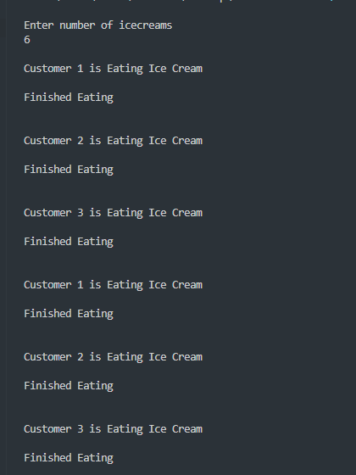

Q2:

sem_t luggageweight, luggagecheck, boardingpass;

void *boardplane(void *arg)

{

    int c = (intptr_t)arg;

    sem_wait(&luggageweight);

    cout << "\nCustomer " << c << " is weighing their luggage";

    sleep(4);

    sem_post(&luggageweight);

    cout << "\n";

    sem_wait(&luggagecheck);

    cout << "\nCustomer " << c << " is checking their luggage";

    sleep(7);

    sem_post(&luggagecheck);

    cout << "\n";

    sem_wait(&boardingpass);

    cout << "\nCustomer " << c << " is getting their boarding pass";

    sleep(3);

    sem_post(&boardingpass);

    cout << "\n";

    return NULL;

}

int main()

{

    sem_init(&luggageweight, 0, 1);

    sem_init(&luggagecheck, 0, 1);

    sem_init(&boardingpass, 0, 1);

    pthread_t customers[10];

    for (int i = 0; i < 10; i++)

    {

        pthread_create(&customers[i], NULL, boardplane, (void *)(intptr_t)(i + 1));

    }

    for (int i = 0; i < 10; i++)

    {

        pthread_join(customers[i], NULL);

    }

}

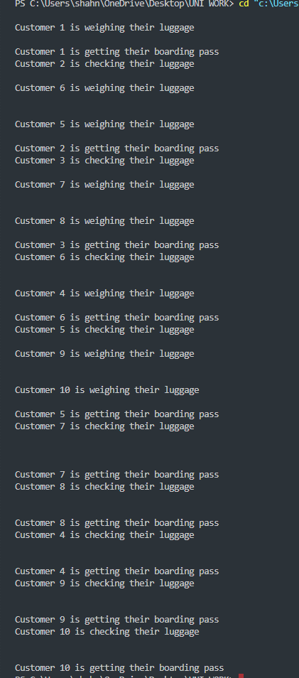

Q3: sem_t ticketaccess;

void *ticket(void *arg)

{

    int c = (intptr_t)arg;

    sem_wait(&ticketaccess);

    cout << "\nTi

cket seller " << c << " is selling tickets, others are waiting";

    sleep(1);

    sem_post(&ticketaccess);

    return NULL;

}

int main()

{

    sem_init(&ticketaccess, 0, 1);

    cout << "\nInput the number of ticket sellers";

    int ticketsellers;

    cin >> ticketsellers;

    pthread_t p[ticketsellers];

    for (int i = 1; i <= ticketsellers; i++)

    {

        pthread_create(&p[i], NULL, ticket, (void *)(intptr_t)(i));

    }

    for (int i = 0; i < 10; i++)

    {

        pthread_join(p[i], NULL);

    }

}

